Insertion Sort:
// Java program for implementation of Insertion Sort
public class InsertionSort {
/* Function to sort array using insertion sort */
void sort(int arr[])
{
int n = arr.length;
for (int i = 1; i < n; ++i) {
int key = arr[i];
int j = i - 1;

/* Move elements of arr[0..i-1], that are
greater than key, to one position ahead
of their current position */
while (j >= 0 && arr[j] > key) {
arr[j + 1] = arr[j];
j = j - 1;
}
arr[j + 1] = key;
}
}

/* A utility function to print array of size n */
static void printArray(int arr[])
{
int n = arr.length;
for (int i = 0; i < n; ++i)
System.out.print(arr[i] + " ");

System.out.println();
}

// Driver method
public static void main(String args[])
{
int arr[] = { 12, 11, 13, 5, 6 };

InsertionSort ob = new InsertionSort();
ob.sort(arr);

printArray(arr);
}
}

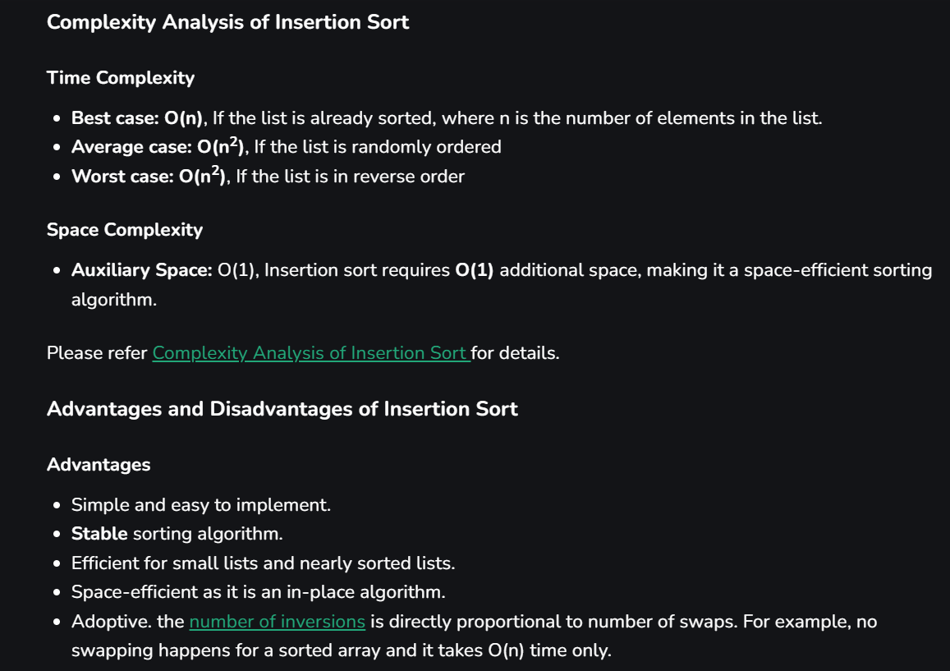
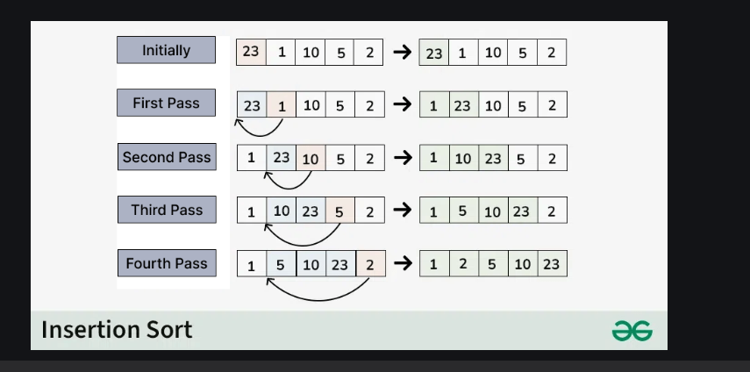

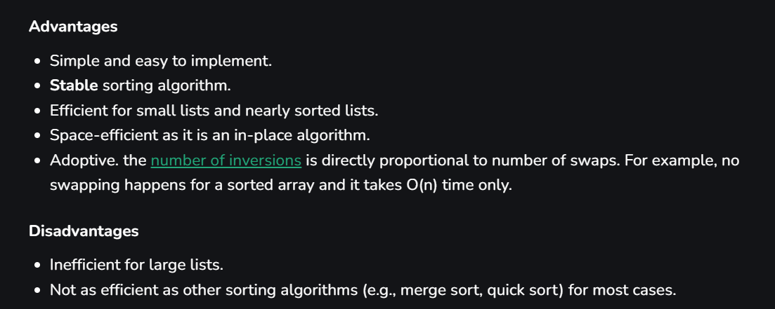

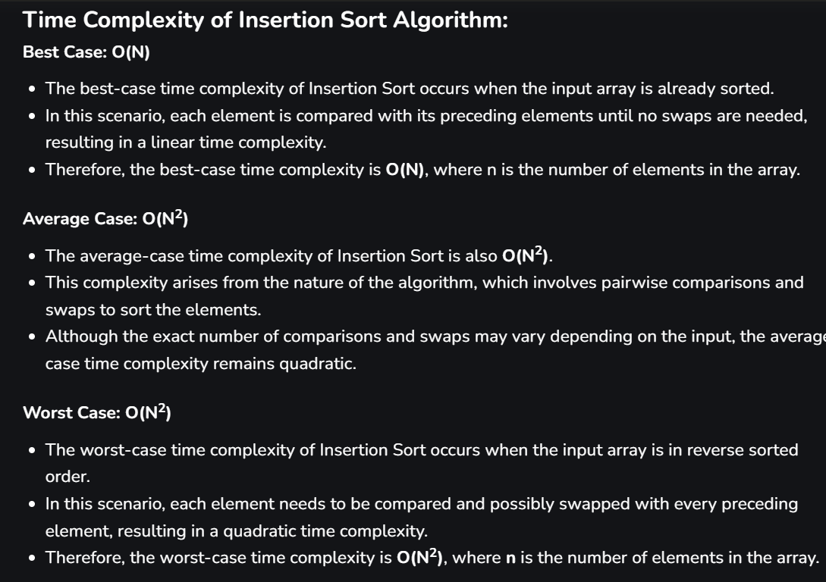

MERGE SORT ALGORITHM
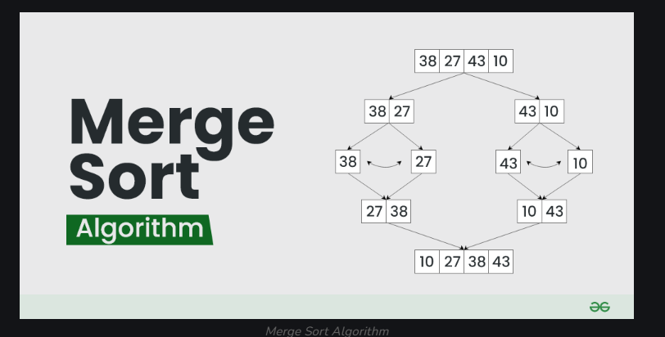

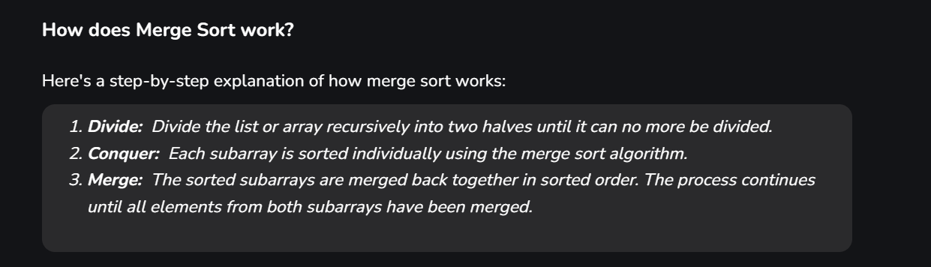

// Java program for Merge Sort
import java.io.*;

class GfG {

// Merges two subarrays of arr[].
// First subarray is arr[l..m]
// Second subarray is arr[m+1..r]
static void merge(int arr[], int l, int m, int r)
{
// Find sizes of two subarrays to be merged
int n1 = m - l + 1;
int n2 = r - m;

// Create temp arrays
int L[] = new int[n1];
int R[] = new int[n2];

// Copy data to temp arrays
for (int i = 0; i < n1; ++i)
L[i] = arr[l + i];
for (int j = 0; j < n2; ++j)
R[j] = arr[m + 1 + j];

// Merge the temp arrays

// Initial indices of first and second subarrays
int i = 0, j = 0;

// Initial index of merged subarray array
int k = l;
while (i < n1 && j < n2) {
if (L[i] <= R[j]) {
arr[k] = L[i];
i++;
}
else {
arr[k] = R[j];
j++;
}
k++;
}

// Copy remaining elements of L[] if any
while (i < n1) {
arr[k] = L[i];
i++;
k++;
}

// Copy remaining elements of R[] if any
while (j < n2) {
arr[k] = R[j];
j++;
k++;
}
}

// Main function that sorts arr[l..r] using
// merge()
static void sort(int arr[], int l, int r)
{
if (l < r) {

// Find the middle point
int m = l + (r - l) / 2;

// Sort first and second halves
sort(arr, l, m);
sort(arr, m + 1, r);

// Merge the sorted halves
merge(arr, l, m, r);
}
}

// A utility function to print array of size n
static void printArray(int arr[])
{
int n = arr.length;
for (int i = 0; i < n; ++i)
System.out.print(arr[i] + " ");
System.out.println();
}

// Driver code
public static void main(String args[])
{
int arr[] = { 12, 11, 13, 5, 6, 7 };

System.out.println("Given array is");
printArray(arr);

sort(arr, 0, arr.length - 1);

System.out.println("\nSorted array is");
printArray(arr);
}
}

Hint: Linked List Merge Sort

